Comments following the MAJICE report.

Background.

HM Courts & Tribunals Service

HM Courts & Tribunals Service is an agency of the Ministry of Justice. It uniquely operates as a partnership between the Lord Chancellor (the Executive), the Lord Chief Justice and the Senior President of Tribunals (the Judiciary) as set out in a Framework Document (memorandum of understanding).
The agency is responsible for the administration of the criminal, civil and family courts and tribunals in England and Wales and non-devolved tribunals in Scotland and Northern Ireland. It provides for a fair, efficient and effective justice system delivered by an independent judiciary.
HM Courts & Tribunals Service aims to ensure that all citizens receive timely access to justice according to their different needs, whether as victims or witnesses of crime, defendants accused of crimes, consumers in debt, children at risk of harm, businesses involved in commercial disputes or as individuals asserting their employment rights or challenging the decisions of government bodies.
From April 2011 the agency employs 21,000 staff operating from around 650 locations. It has a gross annual budget of around £1.7bn, approximately £585m of which is recovered in fees and income from service users. It handles over 2 million criminal cases, 1.8 million civil claims, more than 150,000 family law disputes and almost 800,000 tribunal cases annually.
HM Courts & Tribunals Service works with a range of Government departments and justice agencies to ensure access to justice is provided in the most timely and effective way possible.
The agency's work is overseen by a Board headed by an independent Chair working with non-executive, executive and judicial members. The Board ensures that the agency delivers the aims and objectives set by the Lord Chancellor, the Lord Chief Justice and the Senior President of Tribunals.

HM Courts and Tribunals Service Strategic Objectives

The Framework Document, which sets out the agreement reached between the Executive and the Judiciary for the operation of HM Courts & Tribunals, sets out five key strategic objectives for the agency. Both parts of this partnership seek through their cooperation to achieve the following:

• Provide the supporting administration for a fair, efficient and accessible courts and tribunal system;
• Support an independent judiciary in the administration of justice;
• Drive continuous improvement of performance and efficiency across all aspects of the administration of the courts and tribunals;
• Collaborate effectively with other justice organisations and agencies, including the legal professions, to improve access to justice;
• Work with Government departments and agencies, as appropriate, to improve the quality and timeliness of their decision making in order to reduce the number of cases coming before courts and tribunals.

The Criminal Courts within HM Courts and Tribunal service.

Magistrates’ courts and the Crown Court
Nearly all criminal court cases start in a magistrates’ court, with the more serious offences passed on to the Crown Court.
Key facts about the magistrates’ courts
- There were 422,800 criminal proceedings completed in magistrates’ courts in the fourth quarter of 2011, around six per cent fewer than in the same period of 2010. The trend in recent years has been a decreasing volume of completed criminal proceedings.
- 40,200 trials were recorded in magistrates’ courts, with 43 per cent recorded as effective. Rates of effective (when a trial is commenced), cracked (when a case concludes without a trial) and ineffective (circumstances cause the trial to be postponed) trials in the magistrates’ courts have remained relatively stable during the last three years.

Key facts about the Crown Court
- There were a total of 35,300 cases received in the Crown Court in the fourth quarter of 2011, a four per cent decrease on the number received in the fourth quarter of 2010.
- There were around 9,700 trial listings in the Crown Court in the fourth quarter of 2011, compared to 10,400 in the fourth quarter of 2010. Of these, 46 per cent were recorded as ‘effective ’(when a trial is commenced), with 39 per cent ‘cracked’(when a case concludes without a trial) and 15 per cent ‘ineffective’(circumstances cause the trial to be postponed).
How technology is being used to assist the administration and judiciary to achieve the strategic aims.
1 Management information and performance analysis.
Performance data is captured through HM Courts and Tribunal Service’s IT systems. Thereby enabling the administration and the judiciary to assess the way resources are used and whether the administration of justice is being undertaken in a timely and efficient way.
While the use of this data is key for the administration to understand how successful its operations are the same is not true of how the judiciary use the available data. There is no measure of how ‘successful’ judicial decisions are. The judiciary operate independently and freely to judge cases as set out by the law. With this independence comes a responsibility to do so within the available resources and in a way proportionate to the seriousness and complexity of each case.

Timeliness of criminal proceedings is a key indicator of how resources are being used. National indicators of this measure are used as guides for courts as to how their behavior compares to the overall picture of performance. For example the average time to conclude a case from its commission to disposal at a court hearing is 155 days. The question for each court to ask is how do we compare to this national average? A question both the administration and judiciary ask themselves.

Table one is an example of how timeliness data is presented to distinguish performance for serious (defined as indictable/triable either way cases), minor criminal cases ( defined as summary non motoring) and cases involving motor vehicles which are dealt with in the criminal courts (defined as summary motoring). The term ‘charge’ is the point at which the police refer the case to the prosecution.
Table 1: Average time taken from offence to completion, for all defendants in completed criminal proceedings by offence 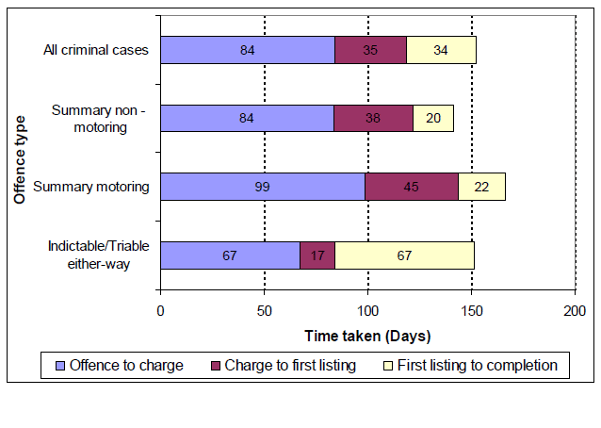
Further examples of the wide ranging measures available can be accessed through the following website
http://www.justice.gov.uk/statistics/criminal-justice/criminal-justice-statistics
2 Digitalisation
Transforming Through Technology - T3 - is the programme that is moving the Crown Prosecution Service (CPS) from paper-based processes to a full digital way of working. This programme will improve efficiency and remove many of the frustrating tasks and the bureaucracy associated with our existing, paper-based systems.
Six lead court areas - 'Early Adopter Sites' - have been testing aspects of digital working throughout 2010-11, going as far as possible to move away from paper and work digitally with partner agencies. Their experiences continue to be captured, transformed into a set of best practice tools, and shared with other areas, who can then quickly implement the tested processes.
During 2010-11, work began to upgrade the CPS's existing technology infrastructure and software to provide increased digital capacity and capability.
Changes have been made to enable a two-way exchange of data between the police and the CPS and to broaden the range of information that can be transferred through the CJS Exchange to enable greater digital working.
Early T3 achievements for 2011-12 include prosecuting lists at Court directly from a hand held computer, and increasing the use of electronic presentation of evidence in the most complex cases.
3 Video conference technology.
Many prisons are now using state-of-the-art video systems to link to Crown and Magistrate courts. Prison Video Links (PVLs) allow offenders to appear in court via a live video link from prison.
PVLs are primarily used for court hearings and legal visits, but they can also be used for a number of other purposes such as probation and official visits, inter-prison visits and staff training.
There are many benefits of video linking including:
- protection of witnesses and victims in court
- improved security
- financial savings
- care for vulnerable prisoners
- less disruption of prison regime
- reduction of escape risk
- reduction of drugs/weapons risk
The technology required to establish a video link is relatively simple. A screen and camera with a microphone are installed at each location. An ISDN (high-speed) telephone line is used to transmit the sound and pictures electronically between the locations.
PVLs can also be used to electronically present evidence such as original papers and documents. Offensive and dangerous weapons can be shown by video or CD-Rom to prevent people from having to handle them and possibly be injured.
In England and Wales there are currently 58 prisons linked up to 32 Crown Courts and 153 Magistrate Courts. In the future, video links may be extended to additional Courts, Prisons and other Government departments, authorities and agencies.
4 The Transparency agenda, improving access for the public.
XHIBIT is an example of the way the above is being achieved.

XHIBIT improves the daily business of every Crown Court in England and Wales by providing hearing information to those who need it within minutes. XHIBIT is the first step in joining-up the Criminal Justice System.
What does XHIBIT do..?
Contributing to swifter justice, XHIBIT sends vital hearing information from the courtroom to:
- Police; Victims and Witnesses; Probation; Crown Prosecution Service; Prisons; Magistrates' Courts; and Youth Offending Teams
Paper records and hand written logs will be a thing of the past as Court Clerks record Crown Court events as they happen using new technology in every court.
Potential Benefits of XHIBIT
- Faster updating of the Police (PNC) National Computer; fewer unnecessary adjournments; fewer ineffective hearings; better witness management;
- Distributing information much more efficiently across the Criminal Justice System (CJS);reduced solicitor waiting times; improved experience of victims and witnesses ;and
- Increased visibility of hearing progression; improved communication among court staff.
The rollout of XHIBIT was completed on 31 March 2006. For an example of what XHIBIT can do please go to http://xhibit.justice.gov.uk/xhibit/court_lists.htm
It is important to reflect that the judiciary are content to use the tools mentioned in the above four sections. There is no objection by them that to use them interferes with their independence of action when judging cases.
Enzo Riglia, HMCTS, Head of Crown Court Improvement and Efficiency.

